1. **Describe in a short write up (150-200 words) your process of setting up and installing Flex and Ubuntu/Unix and what IDE you will be using.**

* I worked this assignment on Virtual machin with Ubuntu. As you can see below, I installed flex and bison on Ubuntu. I installed them to write “sudo apt-get install flex bison” on Ubuntu.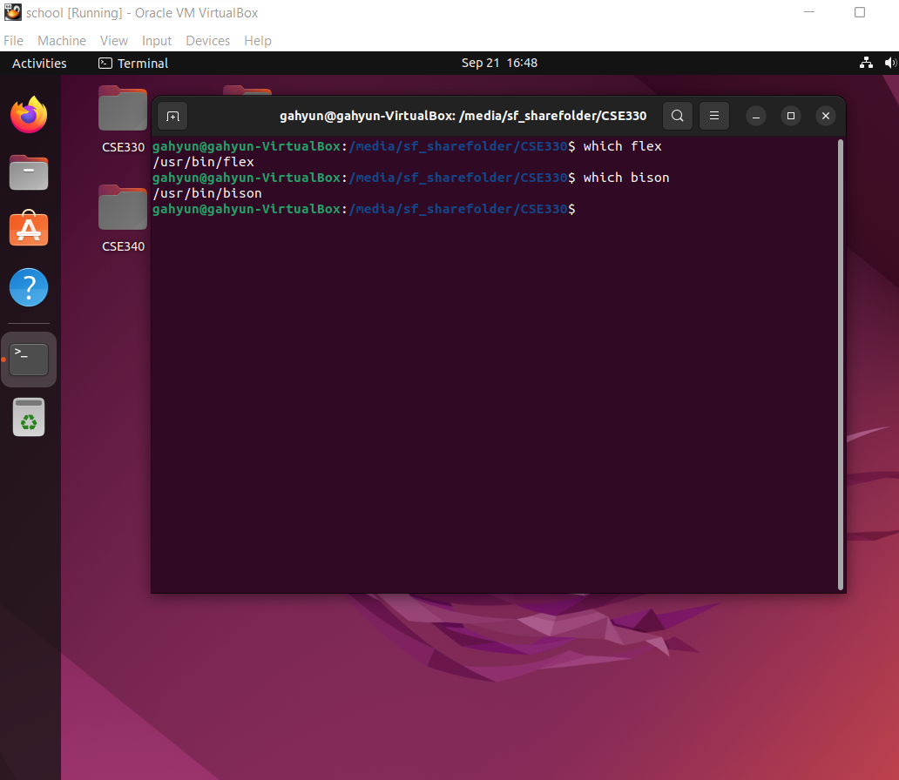
* I also installed Visual Studia Code on my host window as IDE, created .l file on it, and shared the file with Ubuntu on VM. To share the file from host window to VM, there were a few steps to do. I should install Guest Additions on VM, add the directory of the folder I want to share with, mount it. Also I need to add my ubuntu account to vboxsf group to access the sharefolder. After all those steps, I can use my host window and VM together.

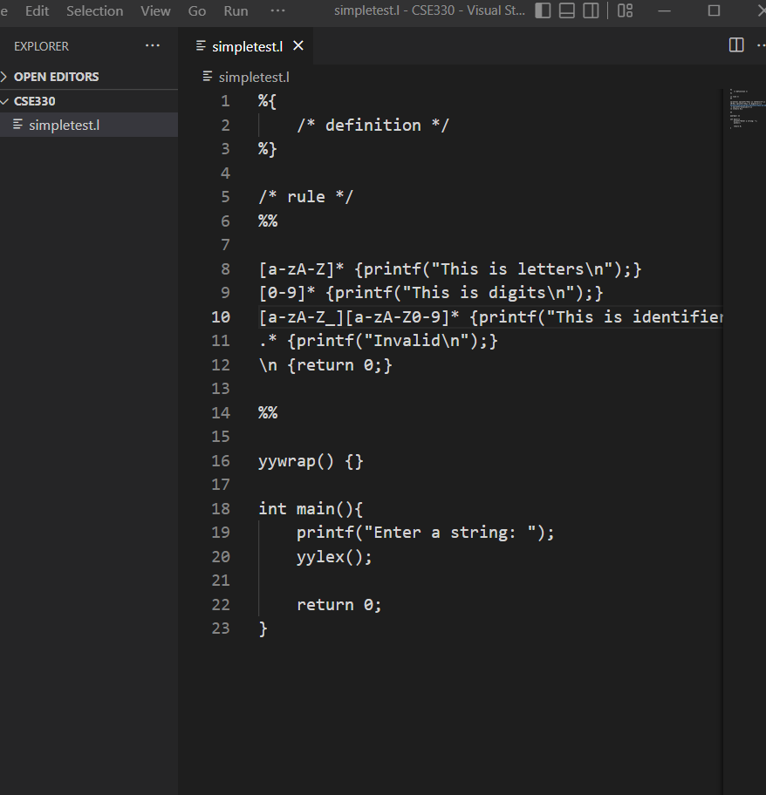

* When I created a “.l” file on VScode, I analyzed input with flex and compiled with gcc on Ubuntu on VM, which generated lex.yy.c file and output file from .l file.

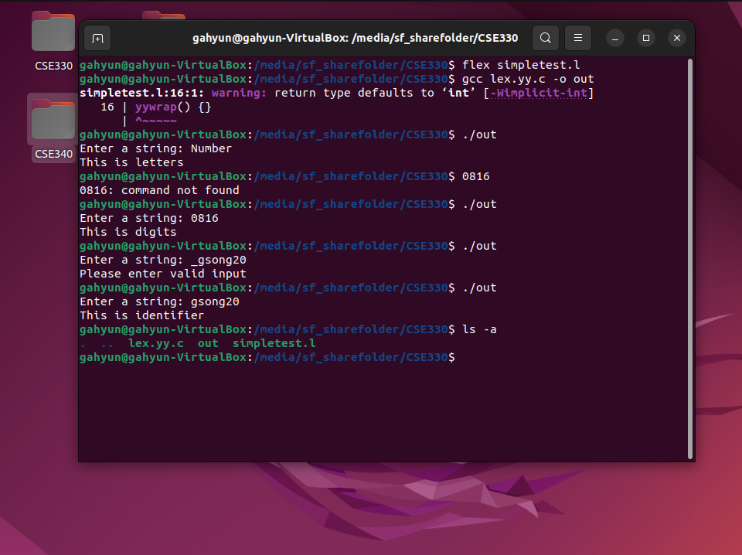

1. **Write a short description of how the Lexer works in compiler design and the files that were generated when you ran you lexer. Describe the tokens you will need to build a full language (this will be project 2). Make sure to describe theoretical principles, design practices, and implementation strategies of #compiler design that you will put into practice.**